Chapter 1 2
Thesis introduction 2
1.1 The BioInorganic Chemistry of Arsenic 2
1.1.1 Metabolism of arsenic 4
1.1.2 Arsenic as a poison 7
1.1.3 Treatment of arsenic poisoning 9
1.1.4 Medicinal applications of arsenic 9
1.2 Chemistry of Arsenic compounds 12
1.2.1 Redox of arsenic by GSH 13
1.2.2 Interaction of arsenic with thiols 15
1.2.3 Lability of the Arsenic Thiol bond 17
1.2.4 Mechanism of arsenic bond lablity 18

Chapter 1

Thesis introduction

1.1 The BioInorganic Chemistry of Arsenic
Arsenic is a group 15 metalloid that is abundant in the earth’s crust (ca, 1.8 ppm) in the form of various minerals. In order to fully understand the bioinorganic chemistry of arsenic, the periodicity and chemical reactivity of arsenic must be appreciated. . As a metalloid, arsenic exhibits a range of class defying properties and has the characteristics of both metal and non-metals. Elemental arsenic is semiconductor, non-ductile and has the capability of forming various allotropes with various crystal structures. Inorganic forms of arsenic include arsenic trioxide (As₂O₃) and varies sulfur compounds such as realgar (As₄S₄) and Oripment (As₂S₃).

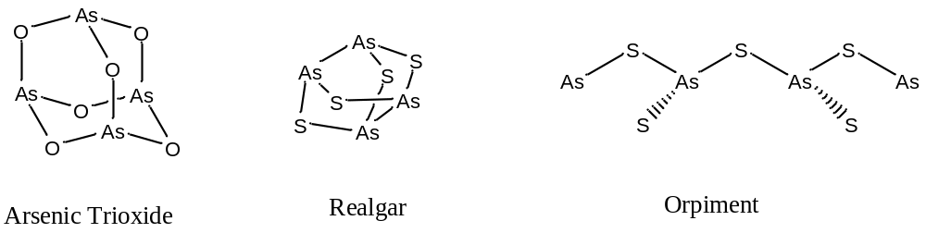
In this way arsenic is similar to phosphorus which also forms a variety of sulfur bond compounds.
The chemistry of organic arsenic compounds just as diverse and varied as its inorganic counterparts. As a pnictogen, arsenic can readily access V, III and -3 oxidation states. Arsenic is closely related to phosphorus in terms of bioinorganic chemistry, and as a result biologically arsenic can occasionally phosphorus act as a phosphorus analogue. For example enzymes that use phosphate as a substrate recognises arsenate¹. However there is one key difference between As and P which is that arsenic has filled inner 3d orbitals and P does not. The 3d orbital sits between 4s and 4p which makes the 4s orbital less accessible². The consequence when compared with P is that As has a more stable oxidation (III) state at the expense of a less stable (V) state. The increased accessibility of the As (III) state gives arsenic access a wide range of different chemistry from phosphorus. It is probably for this reason that As is not ubiquitous in biology whilst phosphorus is readily used in very inert components such as the phosphate backbone of DNA. In fact many arsenic compounds are toxic to biological species, the point where arsenic trioxide has gained the notoriety as the “King of poisons”. Despite its toxicity, arsenic compounds may be required by some biological species. This a contrast to the two heavier elements in group 15, antimony and bismuth, which have no known natural biological function³. In terms of toxicity, antimony has similar toxicity to arsenic, whilst bismuth has minimal toxicity. Bismuth has been used in over the counter products such as Pepto-Bismol to treat heartburn.
This section will focus on the interactions of arsenic within the human body and highlight recent interests and developments.

1.1.1 Metabolism of arsenic
In order to fully understand arsenic’s metabolism by the body, it is necessary to understand that many arsenic species in a constant state of dynamic equilibrium. It is therefore insufficient to just consider one single species, instead an easier way to rationalise the interaction is to consider arsenic as a general system that involves a rapid equilibrium all of the above states. The dynamic nature of the arsenic species will be discussed in greater detail in 1.X. It could be also argued that the chemistry of arsenic has mostly revolved around the stable forms of arsenic⁴, whilst the actual picture is much more distorted as arsenic goes through various unstable and hard to detect species.
Arsenic is ubiquitous in the environment and hence uptake of arsenic by humans is inevitable through food and water. The main form of arsenic that is being absorbed by the body in the inorganic form As (III)⁵. As arsenic is absorbed by the body, it goes through a complicated metabolism pathway that involves a range of oxidation states in addition to methylation on the arsenic. The concern of this section will be focused on the human metabolism of arsenic, however it is important to keep in mind that the metabolism of arsenic between different organisms follows similar patterns⁶. One of the earliest and most referenced study into arsenic metabolism was done by Challenger in 1947 with introduction of the Challenger pathway. Despite its age, Challenger pathway is the framework for which the metabolism of arsenic is rationalised.
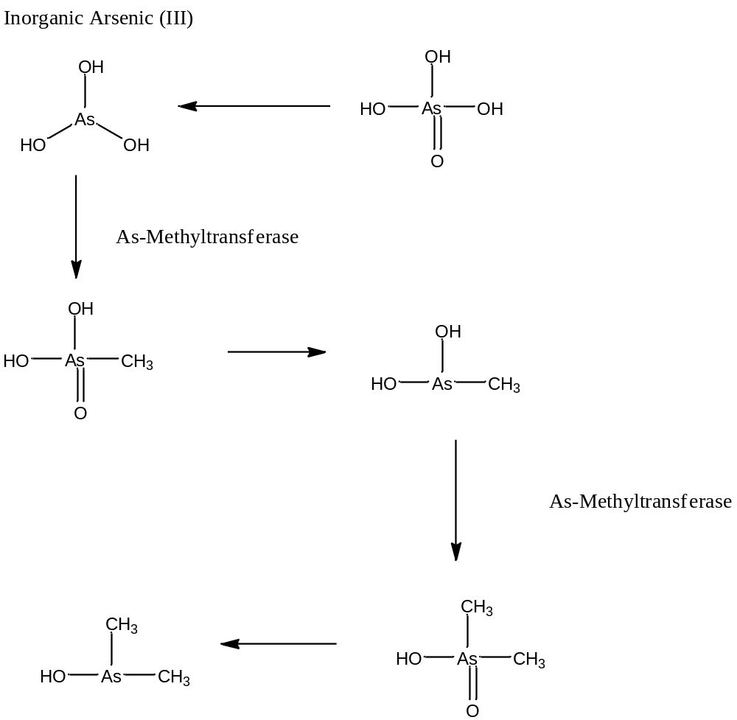
Fig. 1: Challenger’s proposed pathway of arsenic metabolism

Challenger proposed that arsenic is absorbed as As (V), and is reduced to inorganic As (III) by Glutathione (GSH). The arsenite is then methylated and oxidised by As-methyltransferase into mono-methylarsinic acid (V). This is followed by a subsequent reduction to monomethylarsenious acid by GSH. A second methylation then proceeds with the formation of dimethylarsenic acid. Finally the dimethyl arsenious acid. Both methylated and non-methylated species are arsenite are capabile of being removed from the body via the liver into urine. Recent developments⁷ in the metabolism of arsenic has shown there are additional processes that allows arsenic to exchange between various states such as thiodimethylarsenopropanoic acid and thiodimethylarsenobutanic acid. There have be additional revisions to the pathway proposed by Naranmandura and Hayakawa⁸.
It has been suggested that reason for the methylation is to reduce the toxicity of arsenic. However, recently this has be disputed as methylated forms of arsenic are shown to be just as toxic as its inorganic counterparts⁹.

1.1.2 Arsenic as a poison
Arsenic has an infamous history of being the “King of Poisons”, and in famous deaths such as Napoleon and the horse Phar Lap. The LD₅₀ for arsenic trioxide is 35 mg per kg and a fatal dose of could be as low as 100 to 200 mg. The effects of arsenic poisoning appear from half an hour of ingestion. The immediate symptoms include abdominal pain, vomiting diarrhea and salvation and death. There are also long term effects to arsenic poison that include rashes in the form of “arsenicosis”, cancer and damage to the cardiovascular system.

Fig. 2: Example of skin damage caused by arsenic. Taken from google
The exact mechanism of the arsenic interaction is not well established, but it is believed different species of arsenic are responsible a range of toxic responses. The initial symptoms have been proposed to be the result of arsenite (III) binding to viscinal thiols of active enzymes. The binding of arsenic may either cause conformational change in the enzyme or block active sites, hence inhibiting the enzyme their activity. Although has been widely regarded as the mechanism of action, there has been little direct evidence to substantiate this¹⁰. Arsenate (V) have been proposed be toxic in another manner, they are transported into cells via phosphate transport pathways. They then to mimic phosphates and are then included into ATP and DNA⁶. As arsenic can do additional chemistry, this may cause mutations in the cell or cellular damage.
Arsenic’s poisonous attributes is a large issue today as arsenic is found in ground water. This is a result of the leeching of arsenic from the soil into ground water. This presents a major problem for developing countries where wells would bring this toxic ground water up and cause problems in the local populations.

1.1.3 Treatment of arsenic poisoning
Dimercaprol, also known as British anti-Lewisite (BAL), is used metically as a treatment against arsenic poisoning. BAL has a capability of binding very strongly to arsenic via a bi-dentate bond.

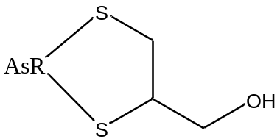

It has been proposed that BAL competes with metabolic enzymes for arsenic binding and hence reduce arsenic’s toxicity. The chelation would result in subsequent removal of the bound compound from the body via urine.

1.1.4 Medicinal applications of arsenic
It has been proposed by Ehrlich that arsenic based drugs would get converted to “RAsO” and would interact with metallothionein. The exact mechanism of interaction is not known as little direct evidence was found to support this theory. The underlying pattern is that many enzymes are inhibited by arsenic, especially those containing thiol (SH) groups.
More recently arsenic trioxide (As₂O₃) was discovered to be effective against the cancer Acute Promeylocytic Leumkemia (APL). APL is a rare form of myeloid leukemia that effects an estimated 1500 new patients each year. The discovery of the drug initially came from traditional Chinese followed by major research developments in the US, leading to FDA approval in 2000 under tradename of Trisenox. In the clinical trial for Trisenox, it was reported that 77% of the 582 patients treated were alive after 3 years, compared with just 50% for non-arsenic treatment. More recently, Ziopharm oncology has developed Darinaparsin, an oxidation state III organoarsenical bound to glutathione for the treatment of APL.

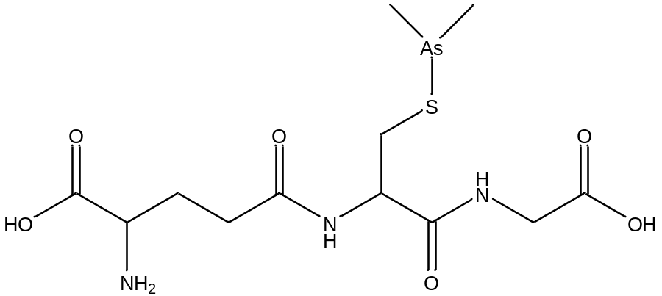
Fig. 3: Structure of Darinparsin
Currently the drug is in Phase III trials and has been shown to be more effective that arsenic trioxide with reduced side effects. This is an interesting drug because it is possible metabolite of arsenic trioxide (see section 1.1.1, the metabolism of arsenic) as Me₂AsOH forms an equilibrium with GSH to form Darinparsin in solution. In addition there are two methyls bound to the arsenic already, preventing it from forming more than 1 bond to thiols.
The mechanism for arsenic in the treatment of APL is not fully understood. Luckily APL is a well-studied cancer and work has been done on the oncoprotein PML-RARα. PML-RARα a fusion protein that of Promyelocytic Leukemia protein PML, and retinoic acid receptor RARα. Zhang et al¹¹ proposed in 2010 that arsenic trioxide interacts the directly the two zinc fingers in PML by replacing the zinc in the zinc finger. They showed using EXAFS that arsenic (III) can interact directly with the sulfurs on the cysteine in the zinc finger.
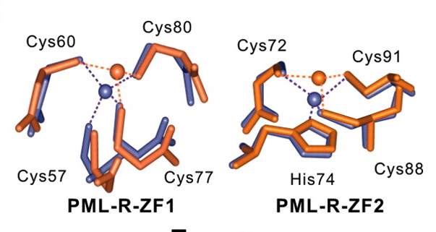
Diagram from Science 2010. Purple: interaction of zinc with the zinc finger. Orange: Predicted orientation of arsenic binding.

They proposed that the coordination of the arsenic causes conformation change in the protein. This change would lead to aggregation of this protein and trigger SUMOlyation and eventual cell death. The exact mechanism in which the arsenic displaces the zinc is relatively unknown and not much additional work has been done on the arsenic interaction in the zinc finger domain. In addition this proposal does not apply for dimethylated arsenic species such as Darinaparsin as the methyl groups take space in arsenic’s co-ordination sphere.
Another proposal for the mechanism of arsenic¹² has been proposed by involves the ability of arsenic to bind to thiols on PML proteins. Once bound, arsenic would form intermolecular disulfide bridges that result in the multimerization of PML into a mesh. It is unclear if arsenic has specificity for the thiols in PML.

1.2 Chemistry of Arsenic compounds
The previous section focused on the biological interactions of arsenic with key one underlying theme: the binding of arsenic to thiols is the key interaction involved in its mechanism of action. This interaction has been profusely by biologists. Despite the frequent use of this concept to explain arsenic’s poisonous attributes, the chemistry of this interaction is not well understood. This section will outline the approaches taken in chemistry to resolve the kinetics and thermodynamics of the arsenic thoil interaction.

1.2.1 Redox of arsenic by GSH
Cullen et al¹³ first discovered the ability of thiols to reduce Me2AsOOH(V) to form Me2AsGSH (III).

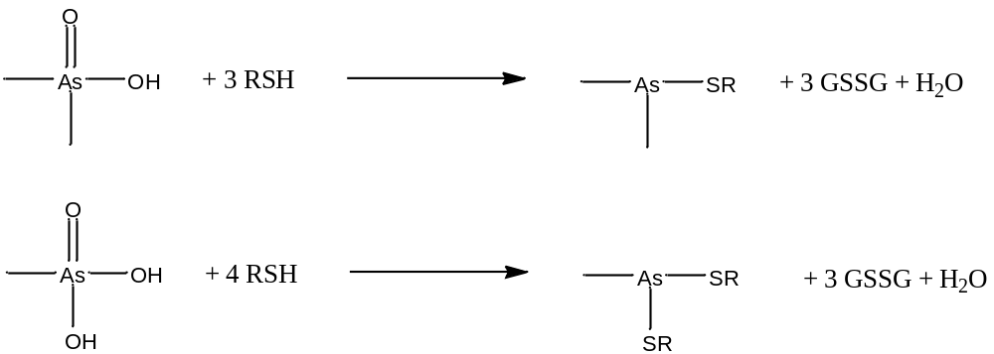
They used a range of thiols such as GSH, Cys and mercaptoethanol which had a range of pkas. They concluded that the thiols did not have to be depronated before this reduction took place as they could perform this reaction in a range of pH below that of the pKa of the thiol.
Delnomdedieu et al¹⁴ built upon this work using modern NMR spectroscopy. They also noticed at as the pH increased, there is the possibility of the formation of free Me2As⁺. This is because even though there was no direct peak for that of free Me2As^{+,} the noticed the chemical shift of the methyl peaks would shift slightly as the pH was increased. They proposed change in the chemical shift was caused by the involvement of an increased amount of Me2As⁺ as solution was basified. Based on this they proposed that the reduction occurred before binding to the thiol. They also noted changes in the spectrum at high pH; the two diastereoteopic methyl peaks would become a single peak. However no kinetic measurement was done on the system.
Carter et al¹⁵ showed the reduction of arsenate to form As(GS)₃

This reaction was found to happen readily at pH 7 and has been fully characterised by 1H and 13 C NMR. They proposed that like for the methylated systems, the arsenate reduction occurred before the binding to GS as a when used a ratio of 1:2 or less, the formation of As(SG)₃ was not observed.
Arsenic (III) species are formed in the presence of a reducing environments. However, in non-reducing aqueous environments, arsenic (III) species are unstable. This has been noted by Cullen et al as they found the Me₂AsCys and Me2AsGS were unstable in solution and rapidly decomposed to their parent oxidation state V acid along with the production of the disulfide.

As a result, they degassed all their solvents prior to use and noted this improved their yields when compared to that of Zingaro et al¹⁶ who performed similar synthesis under aerobic conditions. However, the exact mechanism of this degradation was not fully understood. More recently Zhao et al¹⁷ examined the degradation of the similar system As(GS)₃ using HPLC-ESI-MS. They found that an isomer of α-GSH that was the result of the cleavage of GSSG.
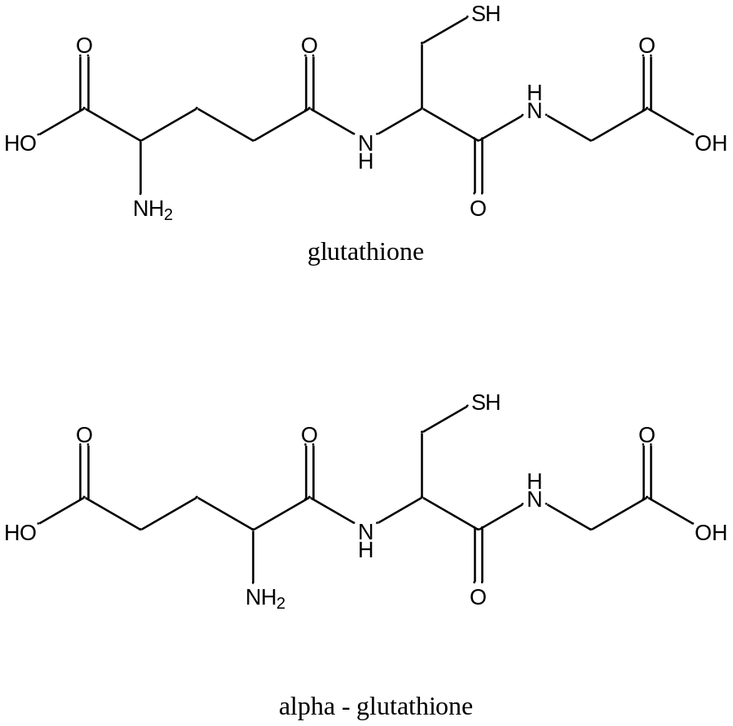
The α-GSH was identified comparing the fragmentation patters of degradation products of As(GS)₃ compared to that of standard GSH. They noted that α-GSH is not normally formed from the degradation of GSSG in the absence of arsenic. The mechanism and reason for the formation of this isomer is not known.

1.2.2 Interaction of arsenic with thiols
One of the well-studied systems in terms of thermodynamics is that of As(OH)₃ and its interaction with Glutathione to form As(GSH)₃. Rey et al¹⁸ used potentiometric and spectroscopic data to show that the formation constant, log K, of As(GS)₃ to be 32. They noted that pH played important role in this interaction
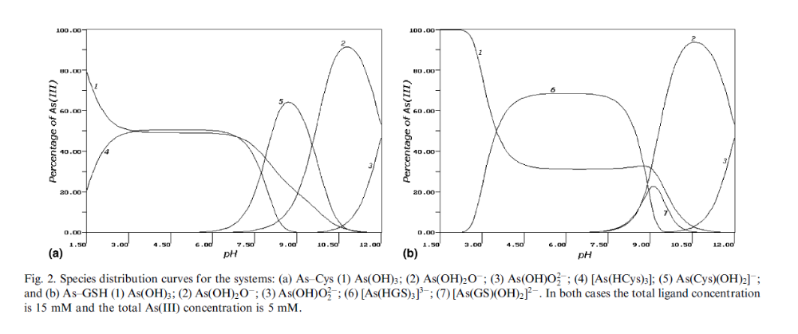
Fig. 4: Figure from Rey et al paper,
Further research has been done by Dean Wilcox¹⁰ who used colormetric and calorimetric studies to quantify the formation constants of arsenothiolates.
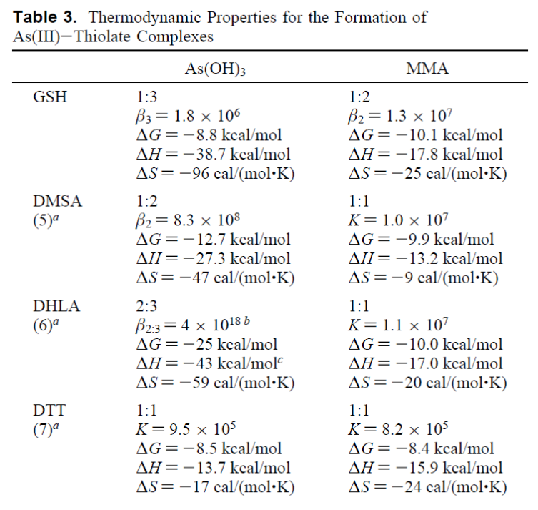
Fig. 5: Thermodynamic properties from Wilcox paper
They found that for As(OH)₃ the binding of glutathione has a stability constant β₃ =2 x10⁶. In addition, they found a co-operative effect in the binding of thiols and the formation constant after each binding in increased. For example ∆H₃ was found to be -33.1 kcal /mol compared to ∆H₁ of -2.5 kcal/mol. They also looked at monomethylarsenite and its equilvalent binding to GSH and found that the binding of GSH to a monomethylated species gave comparable numbers to that of the non-methylated species. Gailer¹⁹ offered an alternative view and proposed after passing both methylated and non-methylated compounds through size exclusion chromatography, the methylated versions were found to be more stable.
Finally they worked out the enthalpy of thiolate displacement to be -2.8 kcal/mol. They also found that there is a large unfavourable ∆S term involved in the binding as a result of the loss of conformational degrees of freedom. As a result they proposed that viscinal thiols that are conformationally constrained will have a higher affinity for arsenic III. This argument extends to conformationally unconstrained Cys residues found in zinc fingers would by this theory have a lower affinity for As (III).
Zingaro et al used the ability of thiols to displace the hydroxyl group in numerous synthesis of new dimethyl arsenious derivatives²⁰.

1.2.3 Lability of the Arsenic Thiol bond
It was found experimentally that as As(SG)₃ was passed through a size exclusion chromatography (SEC)¹⁹, an increase of temperature of the column would cause retention shifts of the arsenic peaks towards small-molecular-mass regions. This is indicative of labile arsenic sulfur bonds which could allow the GS to break away from the molecule.
Arsenic III compounds have the ability are known have labile bonds. The is shown by the ability of meso-2,3-dimercaptosuccinic acid to displace GSH from the complex from As(GS)₃²¹
Arsenic systems have been studied by theoretical chemistry by Orthaber et al²² using DFT calculations with B3lYP/6-31G basis set. They were interested in the interaction of H₂S with Arsenic (V) species

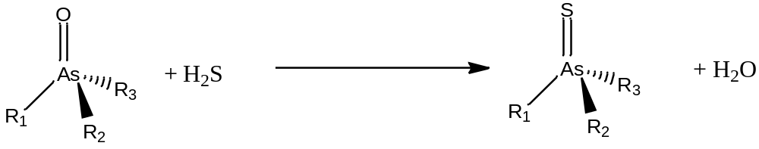

They found that the formation constants is very favorable with ∆G of up to 51 kJ/mol for dimethylarsinoylethanol. Interesting they found that the pentavalent state, the –OH and –SH could interconvert between axial and equatorial positions similar to that of the Berry pseudorotation. They found that the relative intermediate of the interconvertion is 6.7 kJ/mol.
One analogous system for the lability of arsenic is that of Mercury. The mercury thiolate bond has been shown to be labile and capable of rapidly breaking and reforming²³.

1.2.4 Co-ordination and geometry of arsenic compounds
The co-ordination chemistry of arsenic is both rich and diverse. As previously discussed in chapter 1.1, arsenic is a metalloid and can both accept and donate lone pairs. As it result it can accept co-ordination and act as a metal, in addition to donating its lone pair and acting as a ligand.
Edmonds et al²⁴ found that chiral arsenite species are capable rapidly racemizing. The studied this using the chiral arsenite, methylphenylarsinic acid and reacted it with (L)-glutathione to form two diastereomers. The then tried to separate the diastereomers using HPLC
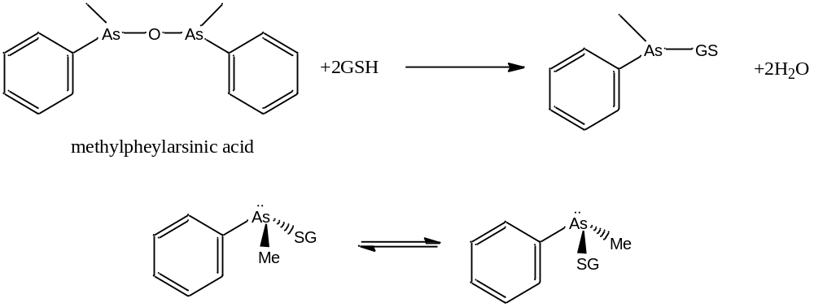
They tried to resolve the diastereomers using NMR spectroscopy with the aid of lanthanide shift reagents and COSY 2D techniques. They were surprised to find that the species have racemized during the purification process (with heating was less than 40°C). The concluded that no pyramidal inversion of the arsenic was seen but could not give a definitive mechanism for this inversion.

1.2.5 Mechanism of arsenic bond lablity
The mechanism under which arsenic can perform its bond lability is not fully understood. Zampella et al²⁵ tried to calculate the binding of structures of arsenite systems using DFT calculations in order to understand how arsenite interacts with thiols of proteins. They modelled the arsenic binding systems with As(CH₃S)₃ and determined that there are two major forms of binding: the endo and exo isomers.
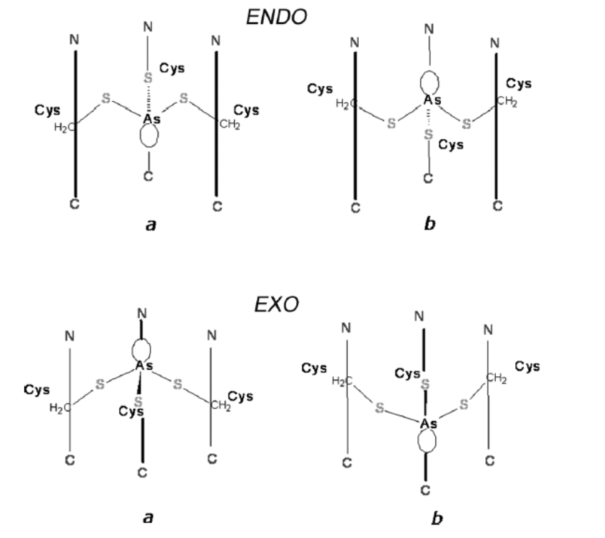
Fig. 6: Diagram from Zampella paper
They concluded that the calculated lowest energy forms were similar to that found in protein systems. This meant that the mode of binding was strongly influenced by the steric bulk of the substituents. They also determined that the direction of the lone pair was a crucial factor influencing the selectivity binding for particular metal ions.
Bibliography
1. Tawfik, D. S.; Viola, R. E., Arsenate replacing phosphate: alternative life chemistries and ion promiscuity. Biochemistry 2011, 50, 1128-34.
2. Levason, W.; Reid, G., 3.6 - Arsenic, Antimony, and Bismuth. In Comprehensive Coordination Chemistry II, Editors-in-Chief: , J. A. M.; Meyer, T. J., Eds. Pergamon: Oxford, 2003; pp 465-544.
3. Sun, H.; Editor, Biological Chemistry Of Arsenic, Antimony And Bismuth. John Wiley & Sons Ltd.: 2011; p 383 pp.
4. Raab, A.; Hansen, H.; Feldmann, J., Labile Arsenic Compounds in Biological Matrices, or Possible Problems Finding the Metal Species Present in Cells. Special Publication-Royal Society of Chemistry 2005, 301, 72.
5. Jomova, K.; Jenisova, Z.; Feszterova, M.; Baros, S.; Liska, J.; Hudecova, D.; Rhodes, C. J.; Valko, M., Arsenic: toxicity, oxidative stress and human disease. Journal of applied toxicology : JAT 2011, 31 (2), 95-107.
6. Cullen, W. R., Is Arsenic an Aphrodisiac? The Royal Society of Chemistry: 2008; p P001-P412.
7. Thomas, D. J.; Li, J.; Waters, S. B.; Xing, W.; Adair, B. M.; Drobna, Z.; Devesa, V.; Styblo, M., Arsenic (+3 oxidation state) methyltransferase and the methylation of arsenicals. Experimental biology and medicine (Maywood, N.J.) 2007, 232, 3-13.
8. Rehman, K.; Naranmandura, H., Arsenic metabolism and thioarsenicals. Metallomics : integrated biometal science 2012, 4 (9), 881-92.
9. Petrick, J. S.; Ayala-Fierro, F.; Cullen, W. R.; Carter, D. E.; Vasken Aposhian, H., Monomethylarsonous acid (MMA(III)) is more toxic than arsenite in Chang human hepatocytes. Toxicology and Applied Pharmacology 2000, 163 (2), 203-207.
10. Spuches, A. M.; Kruszyna, H. G.; Rich, A. M.; Wilcox, D. E., Thermodynamics of the As(III)-thiol interaction: arsenite and monomethylarsenite complexes with glutathione, dihydrolipoic acid, and other thiol ligands. Inorganic chemistry 2005, 44, 2964-72.
11. Zhang, X. W.; Yan, X. J.; Zhou, Z. R.; Yang, F. F.; Wu, Z. Y.; Sun, H. B.; Liang, W. X.; Song, A. X.; Lallemand-Breitenbach, V.; Jeanne, M.; others, Arsenic trioxide controls the fate of the PML-RAR$\alpha$ oncoprotein by directly binding PML. Science 2010, 328 (5975), 240-3.
12. Lallemand-Breitenbach, V.; Zhu, J.; Chen, Z.; de Thé, H., Curing APL through PML/RARA degradation by As2O3. Trends in molecular medicine 2012, 18, 36-42.
13. Cullen, W.; McBride, B.; Reglinski, J., The reaction of methylarsenicals with thiols: some biological implications. Journal of inorganic biochemistry 1984, 21, 179-193.
14. Delnomdedieu, M.; Basti, M. M.; Otvos, J. D.; Thomas, D. J., Reduction and binding of arsenate and dimethylarsinate by glutathione: a magnetic resonance study. Chemico-biological interactions 1994, 90, 139-55.
15. Scott, N.; Hatlelid, K. M.; MacKenzie, N. E.; Carter, D. E., Reactions of arsenic(III) and arsenic(V) species with glutathione. Chemical research in toxicology 1993, 6, 102-6.
16. Chen, G. C.; Zingaro, R. A.; Thompson, C. R., 6-thio and-seleno-[beta]–glucose esters of dimethylarsinous acid. Carbohydrate Research 1975, 39 (1), 61-66.
17. Zhao, F.; Chen, Y.; Qiao, B.; Wang, J.; Na, P., Analysis of two new degradation products of arsenic triglutathione in aqueous solution. Frontiers of Chemical Science and Engineering 2012, 6, 292-300.
18. Rey, N.; Howarth, O., Equilibrium characterization of the As (III)-cysteine and the As (III)-glutathione systems in aqueous solution. Journal of inorganic biochemistry 2004, 98, 1151-9.
19. Percy, A. J.; Gailer, J., Methylated trivalent arsenic-glutathione complexes are more stable than their arsenite analog. Bioinorganic chemistry and applications 2008, 2008, 539082.
20. Banks, C. H.; Daniel, J. R.; Zingaro, R. A., Biomolecules Bearing the S- or SeAsMe2 Function : Amino Acid and Steroid Derivatives. Journal of Medicinal Chemistry 1979, 22, 572-575.
21. Delnomdedieu, M.; Basti, M. M.; Otvos, J. D.; Thomas, D. J., Transfer of arsenite from glutathione to dithiols: A model of interaction. Chemical Research in Toxicology 1993, 6, 598-602.
22. Orthaber, A.; Sax, A. F.; Francesconi, K. a., Oxygen versus sulfur: Structure and reactivity of substituted arsine oxides and arsine sulfides. Journal of computational chemistry 2012, 33, 112-7.
23. Carson, G.; Dean, P., The Metal NMR Spectra of Thiolate. Inorganica Chimica Acta 1982, 66, 157-161.
24. Edmonds, J. S.; Nakayama, T.; Kondo, T.; Morita, M., Diastereoisomerism of thiol complexes of arsenic acids and pseudoasymmetry of arsenic: a 1H and 13C NMR study. Magnetic resonance in chemistry : MRC 2006, 44, 151-62.
25. Zampella, G.; Neupane, K. P.; De Gioia, L.; Pecoraro, V. L., The importance of stereochemically active lone pairs for influencing Pb(II) and As(III) protein binding. Chemistry (Weinheim an der Bergstrasse, Germany) 2012, 18, 2040-50.

